Neuroinclusion and Culturally-Responsive AI Companion Agents for Cognitive and Psychosocial Equity
A Pilot Study for Cognitive Benefits of Characterized AI Companion Agents (Blue) and the Case for Community-Centered Training Data

James Q. Marsh, Psych B.S. Lead Researcher, Mental Wealth Academy research@mentalwealthacademy.net | github.com/Mental-Wealth-Academy
MENTAL WEALTH ACADEMY · RESEARCH WHITE PAPER · July 2026 · Wyoming, USA
Funding alignment: NIH AIM-AHEAD · NIMHD · NSF · EIN 42-3557096
“Investing in the future of humanity, with the heart of tomorrow.”

Abstract
Digital education is shedding the legacy institutional systems that once defined it. As course delivery becomes commoditized, the defining value of digital education platforms are what most software cannot copy: human connection, belonging, and redirection of ambition toward prosocial goals. Mental Wealth Academy (MWA) builds an educational game-world around this thesis, accompanied by an AI companion named Blue. This white paper makes a scientific and equitable case for this design. We argue that a warm, culturally responsive companion agent can lower the social cost of help-seeking, form a digital therapeutic alliance, and deliver two linked classes of benefit: psychosocial and cognitive gains (belonging, engagement, reduced stereotype threat, prejudice reduction) and, as a pre-registered future substudy, biologically measurable stress outcomes. We carefully analyzed the biology. Social adversity and structural racism can become biologically embedded through stress physiology and DNA methylation at stress-axis genes, and — critically — these marks are plastic and potentially reversible. We treat transgenerational epigenetic inheritance as a contested hypothesis, not a premise, and reject genetic essentialism: race is modeled as a social exposure acting through structural context, never as an individual trait. Finally, we show why representative, community-grounded training data are scientific requirements rather than a courtesy, and we align the program with three real funding pathways: NIH AIM-AHEAD, the NIMHD structural-racism research program, and NSF science-of-learning and AI-education solicitations.
01 Introduction: the highest value of college is human connection
For generations, digital campuses meant expensive online resource planning systems. Learning management platforms, such as Blackboard, organize rosters, grades, file storage, and uploads. These 3rd party administrative infrastructures are wearing the costume of education. While technology like generative AI grows in power and commoditizes content delivery and tutoring, the previous monopoly on infrastructure is now seriously losing its claim on value.
We start from a plain observation. When lecture capture, problem sets, and even one-on-one tutoring can be generated on demand, the scarce good is no longer information. It is connection — the structure of showing up, the people met along the way, and the redirection of desire toward goals worth wanting. Students experience burnout in systems that treat them as cogs to be processed. They experience most value, and persist inside communities that make them feel they belong.
The Mental Wealth Academy is a research cohort and educational game world built on that premise. The courses are free and gamified. Progress earns non-tradable reputation points called diamonds — which mark contribution and effort inside the platform’s game. Accompanying the learner is Blue: an AI companion characterized as a friendly, warm, and benevolent scientist. Blue is not a tutor bot and does not provide mental health or financial infrastructure. She is a mental health-aware companion whose warmth is the point.

Thesis
Structure, goal-settings, and reinforced accountability helps redirect parasocial and memetic desires toward prosocial goals. An environment with goals and tools and a fun companion who is silly, and easy to like, lowers the cost of help-seeking, builds a working alliance, and turns engagement into a measurable psychosocial, cognitive, and potentially biological gains.
This study develops the argument in four steps. First, we review why a positively characterized companion can build a therapeutic alliance and reduce prejudice. Second, we explain how chronic social adversity becomes biologically embedded and why this embedding is a plastic rather than rigid. Third, we demonstrate why community-grounded training data is a scientific requirement for any equity claim. Fourth, we laid out a phased study design and mapped it to real funding.
02 Background and prior work
2.1 Prejudice reduction, contact, and parasocial contact
Allport's contact hypothesis proposed that intergroup contact under supportive conditions reduces prejudice¹. A meta-analysis of 515 studies confirmed the effect is robust and generalizes beyond the immediate contact setting ². Contact does not need to be face-to-face. The parasocial contact hypothesis shows that mediated exposure to outgroup characters can reduce prejudice as much as direct contact does ³, and even imagined contact produces measurable improvements ⁴. A broad review of what actually works cautions that effects vary widely by method and that rigorous field evidence is still lacking ⁵. Habit-breaking interventions that build awareness and motivation can produce durable reductions in implicit bias ⁶.
This is important for companion agents. Blue is an encountered character in a parasocial frame. If mediated and imagined contact can shift intergroup attitudes, then a warmly characterized companion plus the perceives virtual and diverse community she convenes is a plausible vehicle for prejudice reduction, provided the design is evaluated rather than assumed.
2.2 Companion agents, likability, and anthropomorphism
The idea that audiences form one-sided bonds with media figures dates to early work on parasocial relationships ⁷, and a recent systematic review extends it to relationships with AI systems as the characters are long-form content, not ephemeral ⁸. People respond socially to media and machines even when they are unsure of if there is a human on the other side ^{[9]}; social responses and cues to computers are automatic rather than deliberate ^{[10]}. Anthropomorphism is stronger when an agent cues human likeness and when users seek connection ¹¹, and a meta-analysis links anthropomorphic design to trust and adoption in service settings ¹². Cuteness carries its own effect: viewing kawaii images measurably increases careful, attentive behavior ¹³. Over time, people form genuine relationships with chatbot companions ¹⁴.
Blue's design is based on anime NPC, she has a compassionate and nerdy affect, futuristic headgear — representing real-life BCI case-studies. It is a deliberate lever on characterization, and likability lowers the social cost of chat and prosocial accountability with wellness goals.
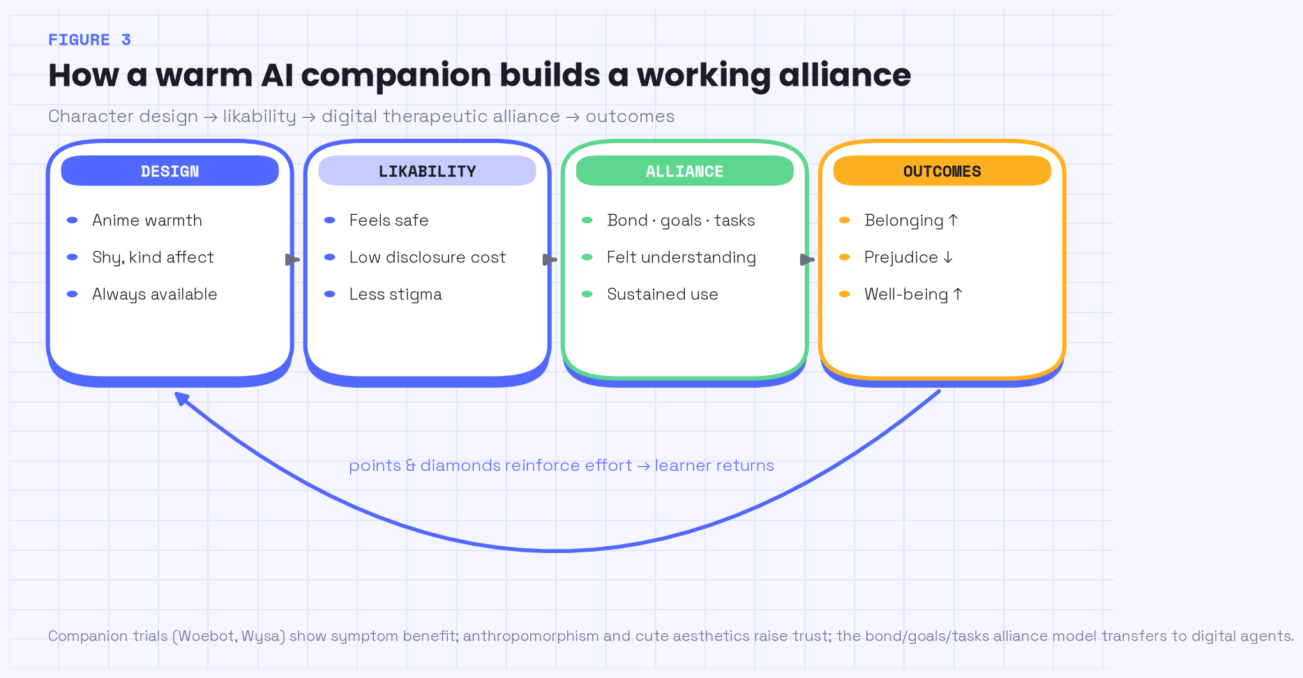
Figure 3. How a warm AI companion builds a working alliance. Character design raises likability, which lowers the cost of disclosure, supports a digital therapeutic alliance, while sustaining engagement and outcomes. Badges, Missions, Quests, and Diamonds reinforce return.
2.3 Therapeutic alliance, digital alliance, and outcomes
The working alliance — the bond between helper and client plus agreement on goals and tasks — is one of the most reliable predictors of outcome in psychotherapy ¹⁵, with validated measurements ¹⁶. The question is whether an alliance can be formed with software. An integrative review found that a digital therapeutic alliance does appear to exist ¹⁷, diary studies documented it forming with mental health chatbots ¹⁸, and user characteristic work maps who forms it and why ¹⁹. Randomized and real-world evaluations of companion agents such as Woebot and Wysa reported symptom benefits in 2021.
2.4 Motivation, gamification, and self-determination
Self-determination theory holds that motivation is sustained when autonomy, competence, and relatedness are met ²³. Well-designed gamification targets these needs. We adopt the framing critically: the same reward mechanics that sustain healthy engagement can, if poorly designed, tip toward compulsive use ²⁴. MWA's answer is to keep it’s point-system (Diamonds) as a reputation signals tied to contribution, not to monetize attention. Prior work on tokenized incentives informs the mechanism design without making financial returns the goal ²⁵.
03 The biology of social adversity
Biology enters this paper as a mechanism for why the psychosocial stakes are high, and as a future measurement opportunity. It is neither a premise, nor a deterministic outcome. The chain of evidence runs from chronic social stress to physiology to gene regulation, and back to plasticity.
3.1 From structural adversity to allostatic load
Chronic stress imposes physiological costs. McEwen's allostatic load model describes how repeated activation of stress response systems produces cumulative wear ²⁶. The weathering hypothesis extends this to populations, showing that the health of Black Americans deteriorates earlier under the sustained burden of social and economic adversity ²⁷. In this framing, race indexes exposure to structural conditions; and it is not a biological cause in itself ²⁸.
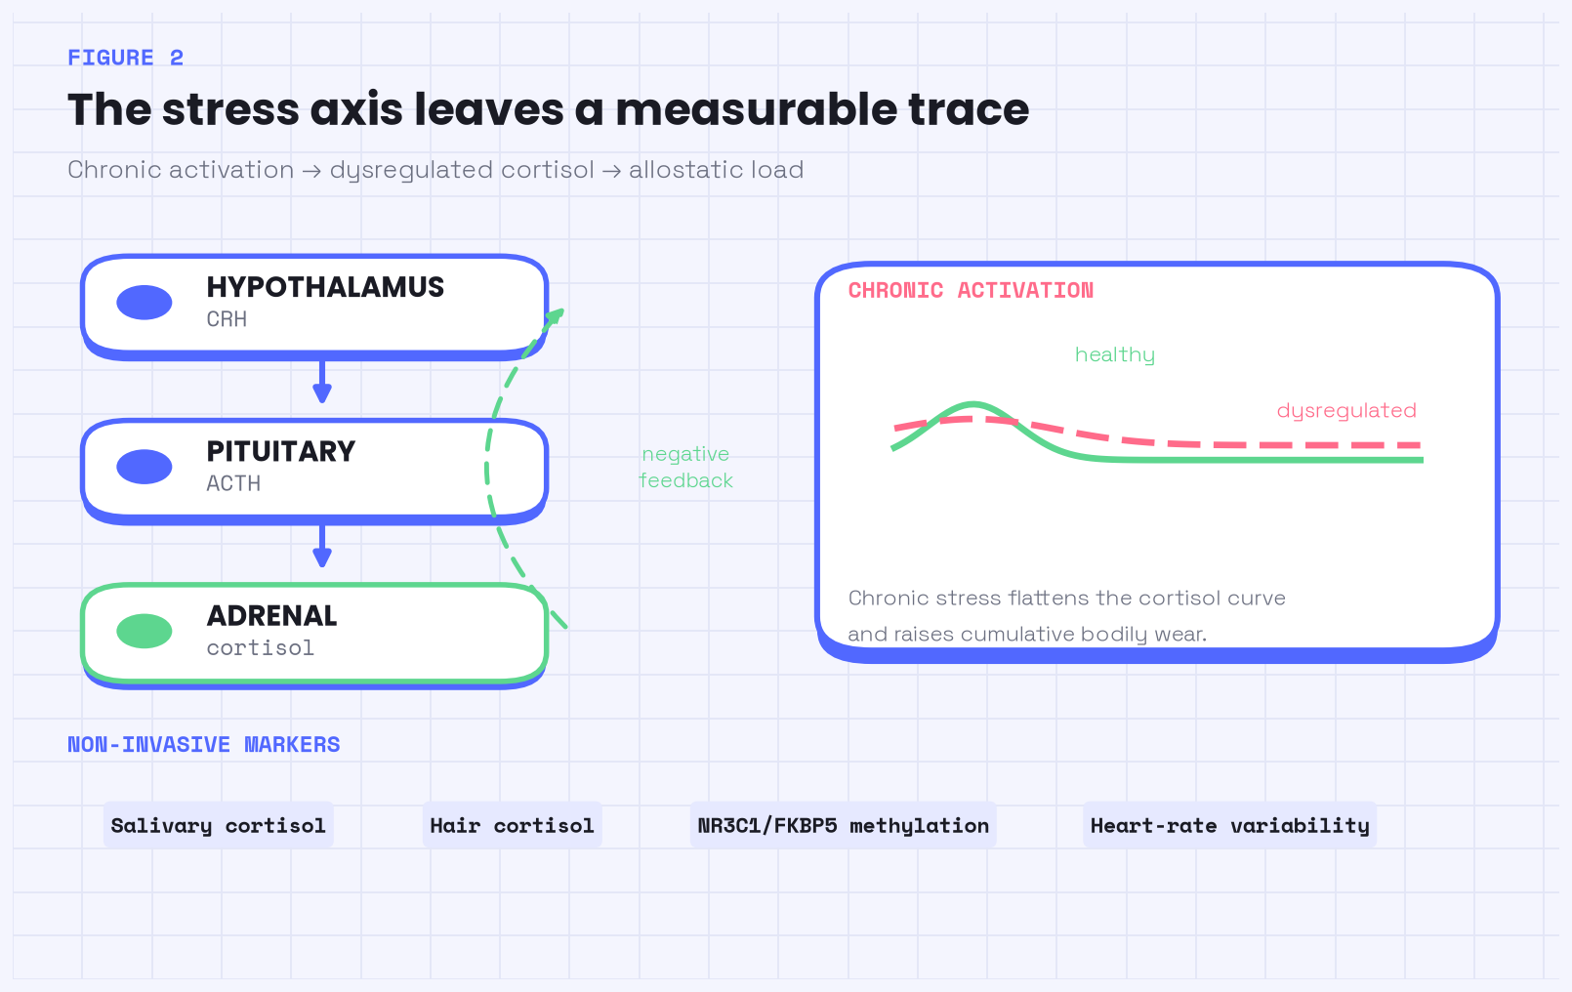
Figure 2. The HPA stress axis and allostatic load. Perceived threat drives cortisol release, and chronic activation dysregulates feedback and accumulates as physiological wear. Structural adversity is an upstream input, not an individual trait.
3.2 Molecular embedding at stress-axis genes
Adversity can leave regulatory marks on the stress-axis genes. Early life experiences are associated with DNA methylation of the glucocorticoid receptor gene NR3C1, which alters stress reactivity ²⁹. Childhood trauma interacts with FKBP5 through allele-specific demethylation, linking experience to lasting changes in stress-hormone regulation ³⁰. These are examples of biological embedding, which are, individual social experiences written into gene regulation.
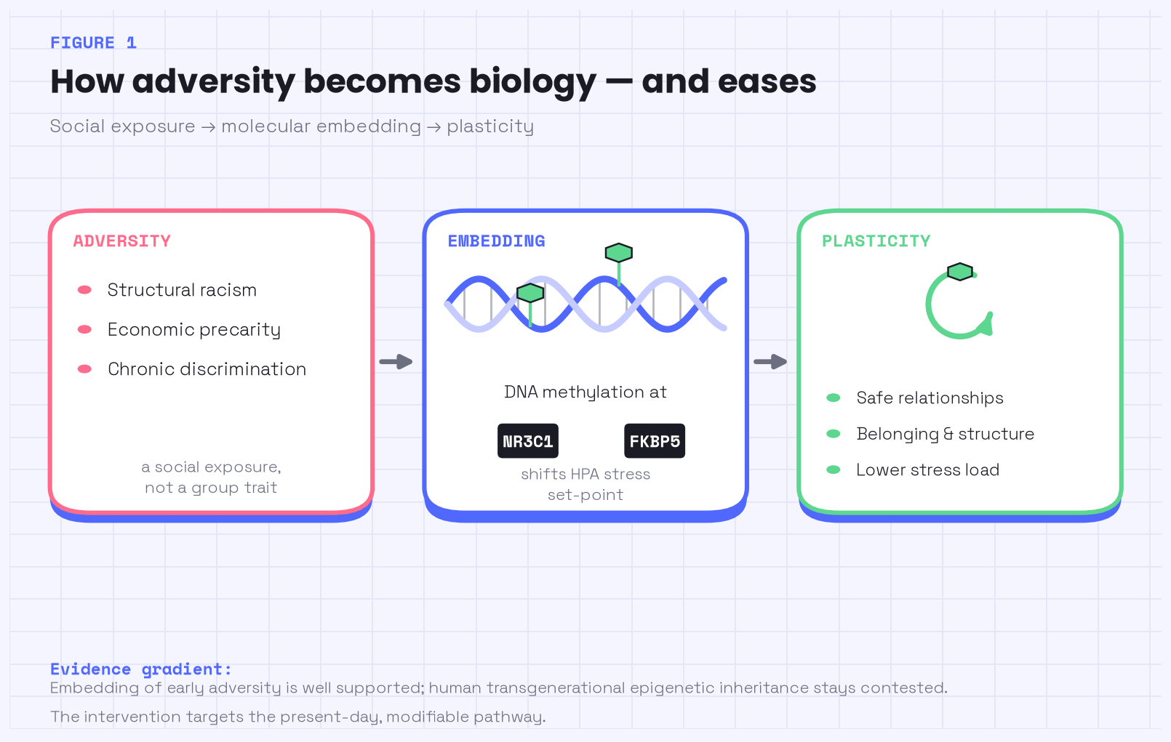
Figure 1. Social adversity becomes biologically embedded — and remains plastic. Chronic stress is associated with DNA methylation at NR3C1 and FKBP5, altering stress reactivity. The marks are potentially reversible, which is what makes psychosocial intervention worthwhile.
3.3 Two hard caveats
Evidence guardrail
Human transgenerational epigenetic inheritance is questionable. We treat it as a hypothesis to be tested, not a fact to build on ^{[31]}. Epigenetic embeddings are not permanent: methylation marks are plastic and potentially reversible, which is precisely why psychosocial intervention can matter biologically.
We are explicit about anti-essentialism. Nothing here implies a genetic difference between racial groups. The causal story is that structural racism produces chronic stress, which can leave modifiable biological traces. The intervention targets exposure and its psychosocial sequelae, and only then asks whether biological markers move.
04 Why community-grounded training data is a scientific requirement
An AI companion inherits the demographics of it's training data. If that data is unrepresentative, or lacking context the technology fails the people it excludes, and hallucinates more. A widely used clinical risk algorithm systematically underestimated the needs of Black patients ³². Commercial facial-analysis systems showed error rates far higher for darker-skinned women than for lighter-skinned men ³³. Dermatology models trained on light skin degrade in quality for the patients at risk ³⁴.
The implications for a culturally responsive companions are direct. If Blue is to reduce prejudice and support belonging for African American learners, she must be fine-tuned to the language, etymology, subtle contexts, and concerns drawn from those communities — with consent, governance, and benefit-sharing. This is the AIM-AHEAD thesis: representative data and participation are prerequisites for equitable AI in health ^{[35]}. This corpus is the scientific foundation of the equity claim.
05 Blue as a companion intervention
Blue is a companion, not infrastructure. Functionally, she accompanies the learner across courses, quests, chat, missions, field notes, and reflections. She reviews submissions, keeps a record of progress, awards points (diamonds) as reputation, and generates learning ontologies. Narratively, she is a benevolent scientist — helpful, short and sweet, a little haunting in her calm. Warmth is engineered to be easy to like, so that help feels safe to ask for.
Points and Diamonds are reputation signals and a currency in the game. They mark contributions and efforts. The reward loop exists to reinforce accountability in prosocial goals and mastery under self-determination principles, and autodiadactism. While making it an enjoyable experience.
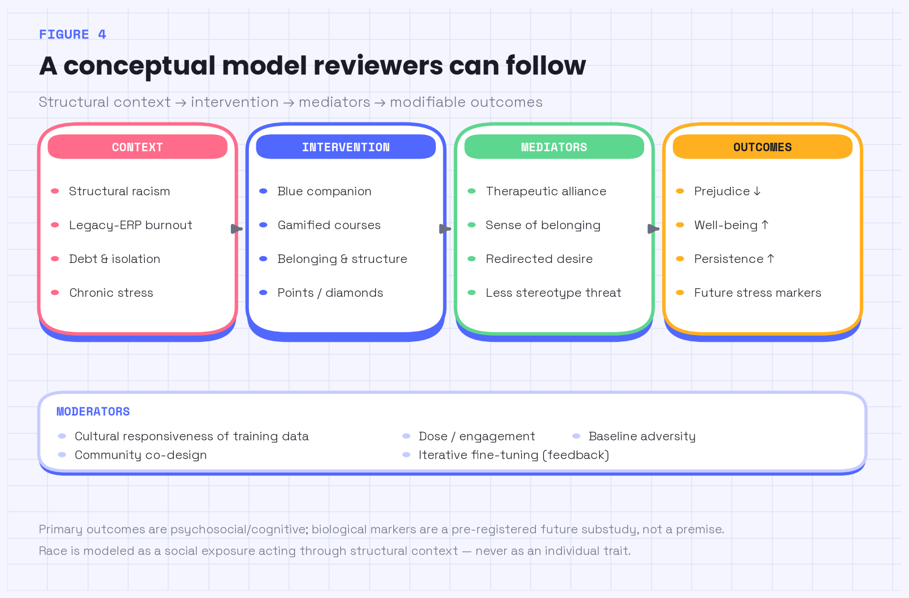
Figure 4. A conceptual logic model. Structural context feeds an intervention (Blue plus gamified, belonging-centered courses), which acts through mediators (alliance, belonging, redirected desire, reduced stereotype threat) on modifiable outcomes. Moderators include the cultural responsiveness of the training data. Biological markers are a future substudy, not a premise.
06 Study design and methodology
We propose a hybrid, phased program that prioritizes psychosocial outcomes and treats biology as a downstream substudy.
6.1 Phase 1 — psychosocial and feasibility RCT
A randomized feasibility trial compared the blue-accompanied game environment against a matched, non-companion version of the same courses. The primary outcomes were prejudice reduction, sense of belonging, well-being, and stronger learning engagement. The secondary outcomes included the strength of the digital therapeutic alliance and reduced stereotype threat. Belonging-intervention methods provide a validated template for brief, well-powered designs ³⁶, and stereotype-threat measures well established for psycholinguistics ³⁷.
6.2 Phase 2 — embedded biomarker substudy
Consenting participants will provide salivary cortisol samples and, optionally, methylation assays at NR3C1 and FKBP5 to test whether psychosocial gains track changes in stress physiology. This phase is pre-registered, opt-in, and explicitly framed as hypothesis-testing given the contested state of the evidence. It maps to an R34-to-R01 progression: feasibility first, mechanism second.
Design at a glance
 | Phase 1 | Phase 2
Design | Feasibility RCT | Embedded substudy
Primary outcome | Prejudice, belonging, wellbeing, engagement | Stress physiology change
Measures | Validated scales + alliance inventory | Salivary cortisol; NR3C1/FKBP5 methylation
Mechanism grant | R34 | R01
07 Cognitive and biological outcomes
The cognitive case is that belonging and a supportive alliance free attention for learning. Reducing stereotype threat improves performance on cognitively demanding tasks ³⁷, and brief interventions that promote a sense of belonging produce durable academic and health gains for marginalized students ³⁶. The biological case is secondary and modest by design: if the intervention reduces chronic stress, we expect measurable movement in cortisol and, potentially, in methylation at stress-axis genes — an empirical question, not a promise.
08 Grant alignment and funding ask
The program is designed to be funded across three real pathways.
- AIM-AHEAD (NIH Common Fund): representative datasets and underrepresented participation in AI/ML for health — the home for the community-grounded data corpus ³⁵.
- NIMHD structural racism and discrimination research: the embodiment pathway from structural racism to health, with modifiable psychosocial and biological outcomes ³⁸.
- NSF science-of-learning and AI-education solicitations: the learning-engagement, gamification, and AI-companion mechanisms ^{[39]}.
The immediate ask funds Phase 1 and the data-governance infrastructure: the feasibility RCT, the community-grounded training corpus with consent and benefit-sharing, and the pre-registration of the Phase 2 biomarker substudy. Anthropic's AI-fluency frameworks inform the learner-facing curriculum on using AI as a thinking partner ⁴¹. Adoption data on AI fluency ⁴² and large-scale educator training partnerships ⁴³ establish both demand and delivery precedents for the curriculum.
09 Ethics and governance
Four commitments govern this study. Biospecimen consent is opt-in, revocable, and separated from platform access. Anti-essentialism is a design constraint: no output, model, or analysis may frame race as an individual biological trait. Privacy is protected by anonymity by default on the platform, with regards to blockchain data being traceable, which is managed by using embedded accounts and data minimization. Governance is participatory — the community grounding the data also shares in decisions about it. The AI Companion’s autonomy are bounded by ethics and open knowledge; while it contains features that transfer items and rewards to users as well as bi-directional chatrooms.
10 Conclusion
The college of the future will not win on content. It will win on connection. Culturally-responsive AI companions fine-tuned or made entirely on marginalized voices and data can make asking for help easy, build a working alliance, and guide engagement into focused psychosocial and cognitive gains — with biological measurement as an honest, secondary question. The equity payoff depends on getting the right data, which is why community-grounded training is the scientific core of this proposal. Small, consistent actions in the present can make the future measurably better.
R References
1. Allport, G. W. (1954). The Nature of Prejudice. Addison-Wesley.
2. Pettigrew, T. F., & Tropp, L. R. (2006). A meta-analytic test of intergroup contact theory. Journal of Personality and Social Psychology, 90(5), 751–783. https://doi.org/10.1037/0022-3514.90.5.751
3. Schiappa, E., Gregg, P. B., & Hewes, D. E. (2005). The parasocial contact hypothesis. Communication Monographs, 72(1), 92–115. https://doi.org/10.1080/0363775052000342544
4. Crisp, R. J., & Turner, R. N. (2009). Can imagined interactions produce positive perceptions? Reducing prejudice through simulated social contact. American Psychologist, 64(4), 231–240. https://doi.org/10.1037/a0014718
5. Paluck, E. L., & Green, D. P. (2009). Prejudice reduction: What works? A review and assessment of research and practice. Annual Review of Psychology, 60, 339–367. https://doi.org/10.1146/annurev.psych.60.110707.163607
6. Devine, P. G., Forscher, P. S., Austin, A. J., & Cox, W. T. L. (2012). Long-term reduction in implicit race bias: A prejudice habit-breaking intervention. Journal of Experimental Social Psychology, 48(6), 1267–1278. https://doi.org/10.1016/j.jesp.2012.06.003
7. Horton, D., & Wohl, R. R. (1956). Mass communication and para-social interaction: Observations on intimacy at a distance. Psychiatry, 19(3), 215–229.
8. Parasocial-AI systematic review authors (2026). Parasocial relationships with artificial intelligence (AI): A systematic review of benefits and risks. Computers in Human Behavior: Artificial Humans. https://www.sciencedirect.com/science/article/pii/S2949882126000757
9. Reeves, B., & Nass, C. (1996). The Media Equation: How People Treat Computers, Television, and New Media Like Real People and Places. Cambridge University Press.
10. Nass, C., & Moon, Y. (2000). Machines and mindlessness: Social responses to computers. Journal of Social Issues, 56(1), 81–103.
11. Epley, N., Waytz, A., & Cacioppo, J. T. (2007). On seeing human: A three-factor theory of anthropomorphism. Psychological Review, 114(4), 864–886. https://doi.org/10.1037/0033-295X.114.4.864
12. Blut, M., Wang, C., Wünderlich, N. V., & Brock, C. (2021). Understanding anthropomorphism in service provision: A meta-analysis of physical robots, chatbots, and other AI. Journal of the Academy of Marketing Science, 49, 632–658.
13. Nittono, H., Fukushima, M., Yano, A., & Moriya, H. (2012). The power of kawaii: Viewing cute images promotes a careful behavior and narrows attentional focus. PLoS ONE, 7(9), e46362. https://doi.org/10.1371/journal.pone.0046362
14. Skjuve, M., Følstad, A., Fostervold, K. I., & Brandtzaeg, P. B. (2021). My chatbot companion — a study of human–chatbot relationships. International Journal of Human-Computer Studies, 149, 102601.
15. Bordin, E. S. (1979). The generalizability of the psychoanalytic concept of the working alliance. Psychotherapy: Theory, Research & Practice, 16(3), 252–260.
16. Horvath, A. O., & Greenberg, L. S. (1989). Development and validation of the Working Alliance Inventory. Journal of Counseling Psychology, 36(2), 223–233.
17. Tong, F., Lederman, R., D'Alfonso, S., et al. (2025). Does the Digital Therapeutic Alliance Exist? Integrative Review. JMIR Mental Health, 12, e69294. https://mental.jmir.org/2025/1/e69294
18. Author(s) of JMIR e76642 (2025). The Digital Therapeutic Alliance With Mental Health Chatbots: Diary Study and Thematic Analysis. JMIR Mental Health, 12, e76642. https://mental.jmir.org/2025/1/e76642
19. Frontiers in Digital Health authors (2025). Exploring user characteristics, motives, and expectations and the therapeutic alliance in the mental health conversational AI Clare®: a baseline study. Frontiers in Digital Health, 7, 1576135. https://www.frontiersin.org/journals/digital-health/articles/10.3389/fdgth.2025.1576135/full
20. Fitzpatrick, K. K., Darcy, A., & Vierhile, M. (2017). Delivering cognitive behavior therapy to young adults with symptoms of depression and anxiety using a conversational agent (Woebot): A randomized controlled trial. JMIR Mental Health, 4(2), e19. https://doi.org/10.2196/mental.7785
21. Inkster, B., Sarda, S., & Subramanian, V. (2018). An empathy-driven, conversational AI agent (Wysa) for digital mental well-being: Real-world data evaluation. JMIR mHealth and uHealth, 6(11), e12106. https://doi.org/10.2196/12106
22. Ryan, R. M., & Deci, E. L. (2000). Self-determination theory and the facilitation of intrinsic motivation, social development, and well-being. American Psychologist, 55(1), 68–78.
23. Ryan, R. M., & Deci, E. L. (2017). Self-Determination Theory: Basic Psychological Needs in Motivation, Development, and Wellness. Guilford Press.
24. Griffiths, M. (2005). A 'components' model of addiction within a biopsychosocial framework. Journal of Substance Use, 10(4), 191–197.
25. Tokenized incentives & smart-contract engagement study (2025). Tokenized Incentives and Loyalty: Leveraging Blockchain-Based Smart Contracts for Enhancing Behavioral Engagement. ResearchGate preprint. https://www.researchgate.net/publication/393354612
26. McEwen, B. S. (1998). Protective and damaging effects of stress mediators (allostasis and allostatic load). New England Journal of Medicine, 338(3), 171–179. https://doi.org/10.1056/NEJM199801153380307
27. Geronimus, A. T., Hicken, M., Keene, D., & Bound, J. (2006). "Weathering" and age patterns of allostatic load scores among Blacks and Whites in the United States. American Journal of Public Health, 96(5), 826–833. https://doi.org/10.2105/AJPH.2004.060749
28. Kuzawa, C. W., & Sweet, E. (2009). Epigenetics and the embodiment of race: Developmental origins of US racial disparities in cardiovascular health. American Journal of Human Biology, 21(1), 2–15. https://doi.org/10.1002/ajhb.20822
29. McGowan, P. O., Sasaki, A., D'Alessio, A. C., et al. (2009). Epigenetic regulation of the glucocorticoid receptor in human brain associates with childhood abuse. Nature Neuroscience, 12(3), 342–348. https://doi.org/10.1038/nn.2270
30. Klengel, T., Mehta, D., Anacker, C., et al. (2013). Allele-specific FKBP5 DNA demethylation mediates gene–childhood trauma interactions. Nature Neuroscience, 16(1), 33–41. https://doi.org/10.1038/nn.3275
31. Yehuda, R., & Lehrner, A. (2018). Intergenerational transmission of trauma effects: putative role of epigenetic mechanisms. World Psychiatry, 17(3), 243–257. https://doi.org/10.1002/wps.20568
32. Obermeyer, Z., Powers, B., Vogeli, C., & Mullainathan, S. (2019). Dissecting racial bias in an algorithm used to manage the health of populations. Science, 366(6464), 447–453. https://doi.org/10.1126/science.aax2342
33. Buolamwini, J., & Gebru, T. (2018). Gender shades: Intersectional accuracy disparities in commercial gender classification. Proceedings of Machine Learning Research (FAccT), 81, 77–91. https://proceedings.mlr.press/v81/buolamwini18a.html
34. Adamson, A. S., & Smith, A. (2018). Machine learning and health care disparities in dermatology. JAMA Dermatology, 154(11), 1247–1248. https://doi.org/10.1001/jamadermatol.2018.2348
35. National Institutes of Health (Common Fund) (2025). Artificial Intelligence/Machine Learning Consortium to Advance Health Equity and Researcher Diversity (AIM-AHEAD). NIH Common Fund. https://commonfund.nih.gov/aim-ahead
36. Walton, G. M., & Cohen, G. L. (2011). A brief social-belonging intervention improves academic and health outcomes of minority students. Science, 331(6023), 1447–1451. https://doi.org/10.1126/science.1198364
37. Steele, C. M., & Aronson, J. (1995). Stereotype threat and the intellectual test performance of African Americans. Journal of Personality and Social Psychology, 69(5), 797–811. https://doi.org/10.1037/0022-3514.69.5.797
38. National Institute on Minority Health and Health Disparities (2025). Understanding and Addressing the Impact of Structural Racism and Discrimination on Minority Health and Health Disparities (R01). NIMHD / NIH Funding Opportunity. https://www.nimhd.nih.gov/funding/active-nimhd-funding-opportunities
39. U.S. National Science Foundation (2025). NSF STEM K-12 and AI Education funding opportunities. NSF 25-545 and related solicitations. https://www.nsf.gov/funding/opportunities/stem-k-12-nsf-stem-k-12/nsf25-545/solicitation
40. Anthropic (2025). AI Fluency: Frameworks and Foundations. Anthropic Courses / Anthropic Academy. https://www.anthropic.com/ai-fluency
41. Anthropic (2025). Discernment — AI Fluency: Frameworks and Foundations. Anthropic. https://www.anthropic.com/ai-fluency/discernment
42. Anthropic (2025). Anthropic Education Report: The AI Fluency Index. Anthropic Research. https://www.anthropic.com/research/AI-fluency-index
43. Anthropic & Teach For All (2025). Anthropic and Teach For All launch global AI training initiative for educators. Anthropic News. https://www.anthropic.com/news/anthropic-teach-for-all

